**Economics of Financial Crisis**

**Yaprak Tavman**

**Introduction to R, RStudio, and ggplot**

If you would like to install R and RStudio on your own machine, below are instructions.

**Downloading R**

Helpful installation videos:

PC: <https://www.youtube.com/watch?v=9-RrkJQQYqY>

Mac: <https://www.youtube.com/watch?v=5-ly3kyxwEg>

1. Download R <https://archive.linux.duke.edu/cran/index.html>
   1. **PC users:**
      1. Choose the “Download R for Windows” option

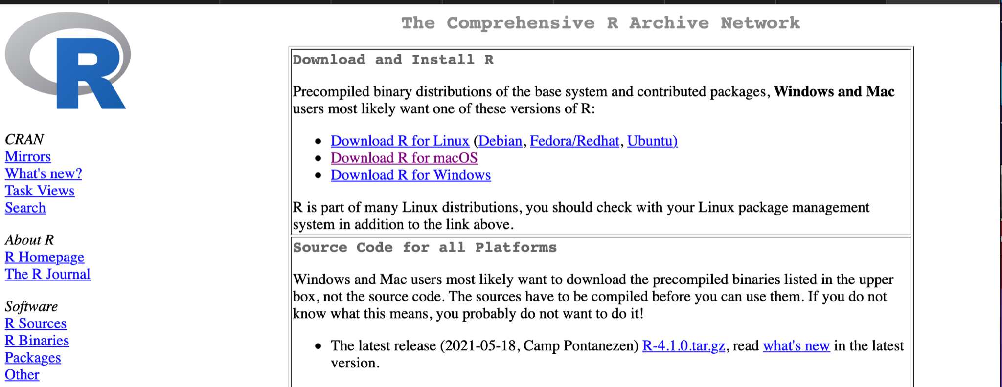

* + 1. Click the “base” option

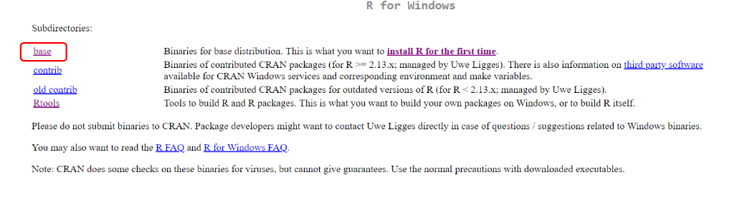

* + 1. Click “Download R 4.1.0 for Windows”

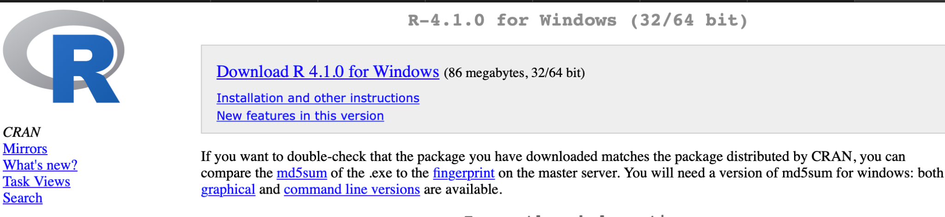

* + 1. Then go back to the above link, click “Rtools” instead of “base”

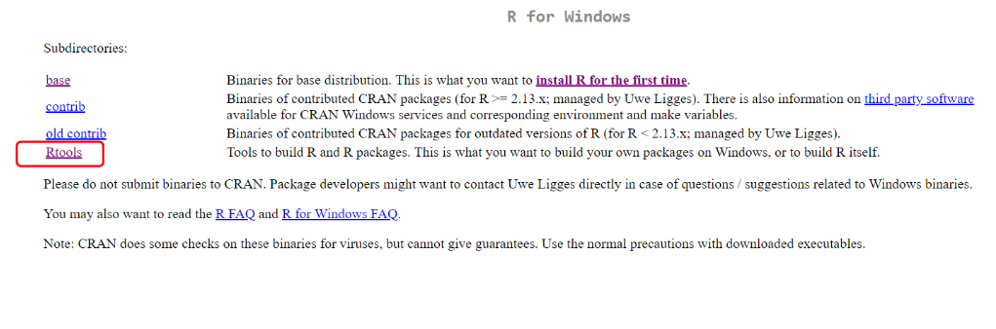

* + 1. Click on the recommended version to download.

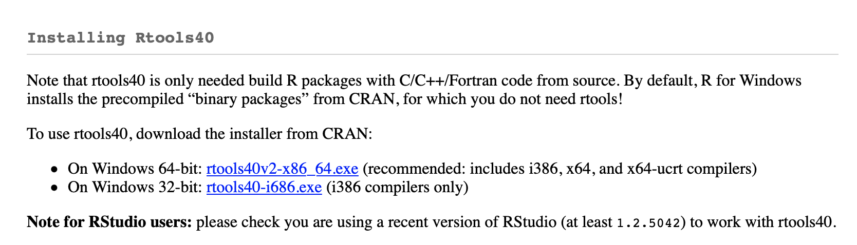

* 1. **Mac users**:
     1. Choose the “Download R for Mac OS” option



* + 1. install the **latest release package best-suited for your system** (High Sierra or Big Sur)

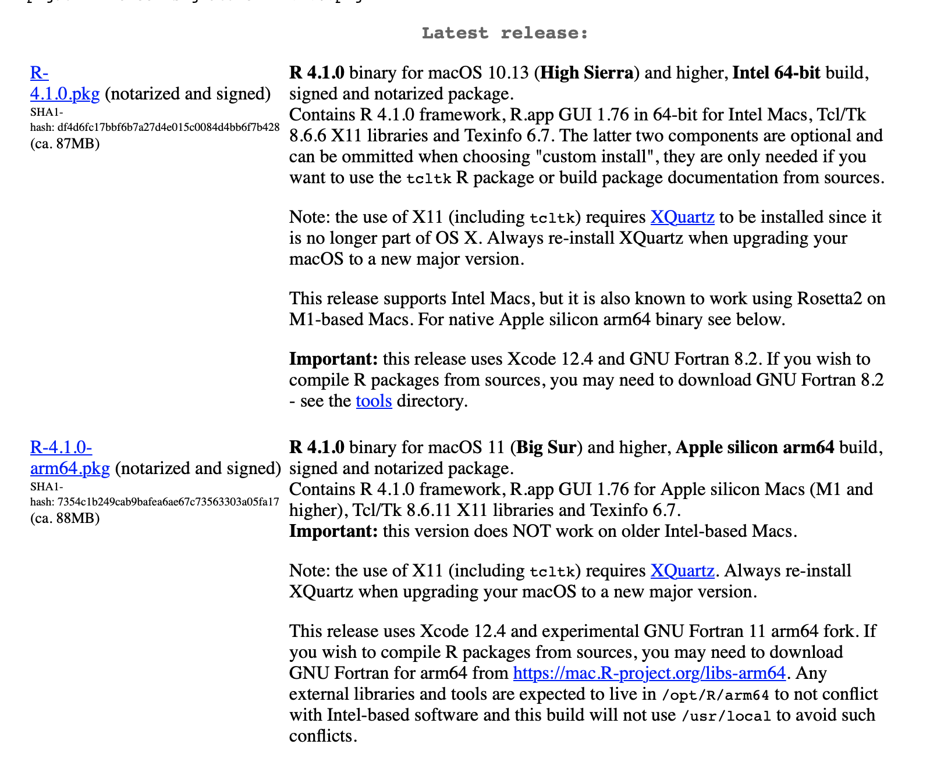

1. **PC and Mac-** Download R Studio: <https://www.rstudio.com/products/rstudio/download/>
   1. Scroll down to the “Installers for Supported Platforms” and choose which installer you will need for your computer

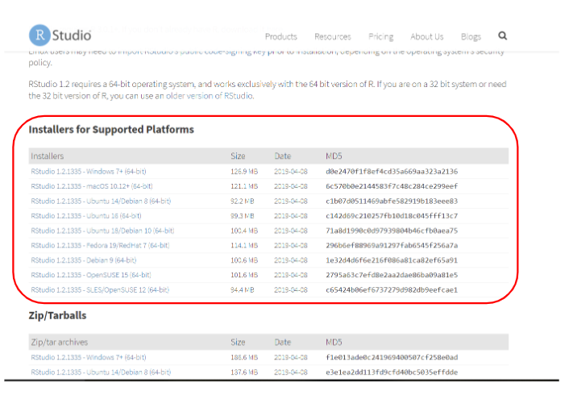

1. **PC and Mac**- Go through the setups of the R and R Studio download until you are finished with both! (The videos walk you through each window of each setup box - you don’t need to adjust any settings for each)

**Downloading ggplot2**

R packages page [**https://www.rstudio.com/products/rpackages/**](https://www.rstudio.com/products/rpackages/)

**Click ggplot2. Click project site link (**[**https://ggplot2.tidyverse.org**](https://ggplot2.tidyverse.org)**)**

**R vs. RStudio vs. R Markdown vs. R Notebooks**

R: The basic software environment to run the R programming language. You can Use R without having to download RStudio.

RStudio: An integrated development environment (IDE) [read: easier user interface] for programming, usually R. You need to download R to use RStudio (but recently other languages could be used for RStudio, too).

R Markdown: A file format for making dynamic documents with R. An R Markdowndocument is written in markdown (an easy-to-write plain text format) and contains chunks of embedded R code

R Notebooks: An R Markdown document with chunks that can be executed independently and interactively, with output visible immediately beneath the input.

**Saving**

Be sure to have a comprehensive setup of your data. Make sure there is an R Projects folder saved somewhere you can find it, holding all of the projects you work on using R. Be clear with how you name your subfolders and datafiles, as you will have to find them later when setting up your working directory in RStudio.

**ggplot2**

ggplot2 is an open-source data visualization package meant for use with the programming language R. The software is free to download and install on personal computers.